See last associates degree program archives for online lecture.
Week 2 Readings
Complete the following readings early in the week:
- Read the Week 2 Online Lectures.
- Read pages 2 – 9 and 34 – 51 from the textbook, Atlas of Human Anatomy for the Artist.
- Read pages 110 – 121 from the textbook, Atlas of Human Anatomy for the Artist.
- Read pages 128 – 137 from the textbook, Atlas of Human Anatomy for the Artist.
- Read pages 70 – 85 from the textbook, Figure Drawing Techniques by Greg Albert.
Week 2 Assignments Overview
Assignment Summary: Week 2 | Due Date
Assignment 1: Lower Limb—Anatomy Drawing | Tuesday, July 22, 2008
Assignment 2: The Trunk—Anatomy Drawing | Thursday, July 24, 2008
Assignment 3: The Pelvis—Anatomy Drawing | Saturday, July 26, 2008
Remember that all Assignment details can be found on the assignment pages located throughout the week. Go to those specific pages for direction on how to complete each individual assignment.

Assignment 1: Lower Limb - Anatomy Drawing
By Tuesday, July 22, 2008, draw one (1) view of the skeletal system of the leg (Peck 6) and one (1) view of the muscular system (Peck 132-133) of the leg. Submit your responses to the appropriate Discussion Area. Review and critique the work of at least two other students early in the week.
Please be sure to resize and optimize your drawings before posting.
Next, answer the following questions:
- How successful were your drawings?
- What did you learn about the muscle and bone structure of the leg?
Example:
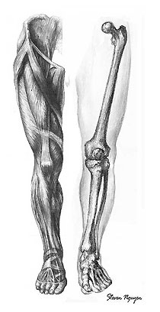

Assignment 1 Grading Criteria | Maximum Points
Completeness of assignment—all elements listed above are included in the assignment. | 4
Balance, scale and proportion, sketch and value, and overall unity of elements. | 4
Clean, well crafted, and technically sound work. | 4
Student uses terminology and relates concepts introduced in course studies throughout discussion contributions. Student brings additional questions and observations into the discussion. | 4
Student communicates ideas in a manner that is clear and complete, leaving no implied information. | 4
Discussion contributions adhere to project specifications regarding format, focus, and deadline. | 4
Participation in discussion with class, feedback and comments. | 4
Total: | 28
For assistance with any problems you may have when completing this assignment—OR—to offer your assistance to classmates, please use the Problems and Solutions Discussion area located through the left side navigation link.
Assignment 2: The Trunk – Anatomy Drawing
By Thursday, July 24, 2008, please draw and submit your responses to the appropriate Discussion Area:
1. The skeletal system of the ribcage (front view) and vertebral column and,
2. Draw the muscular system of the trunk (front view).
Reference: pages 23-29 and 6-7 in Atlas of Human Anatomy for the Artist.
Review and critique the work of at least two other students early in the week.
Example:
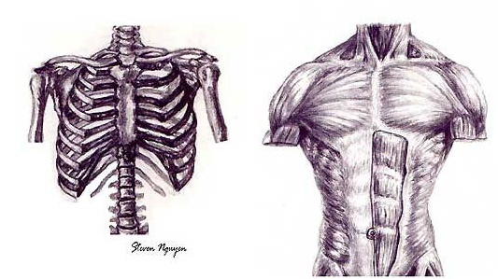

Assignment 2 Grading Criteria: | Maximum Points
Balance, scale and proportion, sketch and value, and overall unity of elements. | 4
Accuracy and proportion of the forms. | 4
Clean, well crafted, and technically sound work. | 4
Participated in discussion with class, feedback and comments. | 4
Total: | 16
For assistance with any problems you may have when completing this assignment—OR—to offer your assistance to classmates, please use the Problems and Solutions Discussion area located through the left side navigation link.
Assignment 3: The Pelvis – Anatomy Drawing
Post your completed work to the appropriate Discussion Area by Saturday, July 26, 2008.
1. Please study and draw the skeletal system of the pelvis (Peck 61).
2. Please study and draw the muscular system of the pelvis (Peck 104).
Review and critique the work of at least two other students early in the week.
Example:
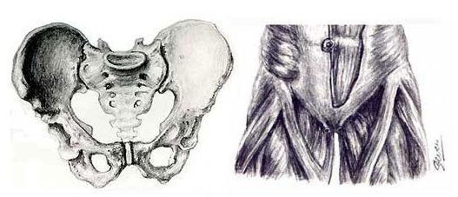

Assignment 3 Grading Criteria: | Maximum Points
Accuracy and proportion of the forms | 4
Completeness of the assignment-all elements correctly depicted | 4
Clean, well crafted, and technically sound work | 4
Participated in discussion with class, feedback and comments | 4
Total: | 16
For assistance with any problems you may have when completing this assignment—OR—to offer your assistance to classmates, please use the Problems and Solutions Discussion area located through the left side navigation link.

